EMGT 554/CCE 554 Professional Responsibility and Ethics

Final Exam
Lucas Swanson
9/02/2026

ANSWER ALL QUESTIONS

- Construct a table or a Venn diagram with a summary of the following ethical perspectives: Duty, Utilitarian, Common Good, and Virtue. Reflect on the similarities and differences between the perspective shown in your diagrams (2 points). What are the advantages of considering an ethical issue from multiple perspectives (2 points).
Answer #1
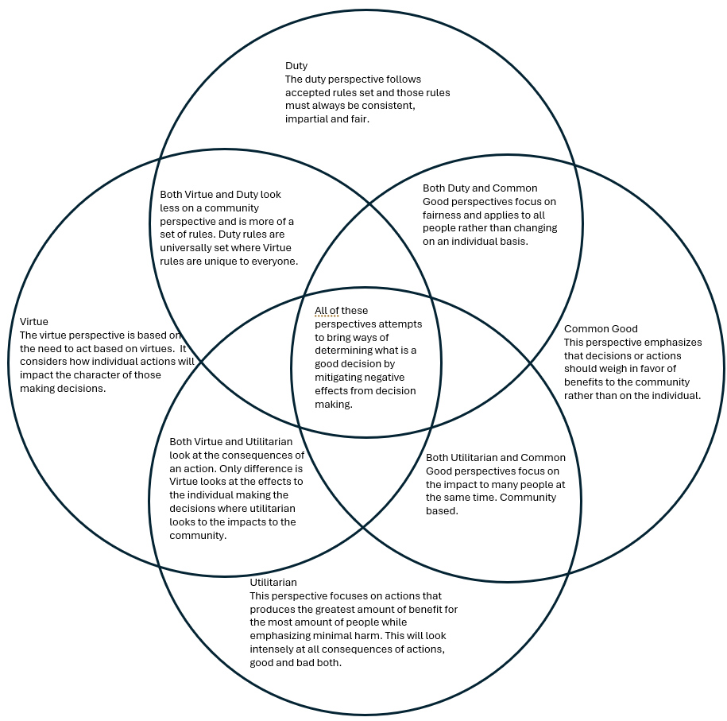
This diagram goes into the descriptions and similarities between the ethical perspectives of Virtue, Duty, Common Good, and Utilitarian. But for the second half of the question some ways it is beneficial to look at more than one perspective because they all are focused on different areas. For example, only looking at the Virtue perspective is limited in scope as it only extends to the individual making the decisions, rather than the impacts to the community that decision had. Combining it with the Utilitarian perspective lets you get both a perspective focused on keeping an individual aligned with their own moral compass as well as focusing on community good and rejecting choices with negative consequences.
- Imagine that you are part of a professional ethics committee. Craft an argument to convince a skeptical colleague that the last step of the ethical decision-making process (reflect) is an important part of ethical decision-making. (2 points).
Answer #2
Reflection is not simply a box to check after evaluating possible actions, it is part of the decision making process. According to (Velasquez, 2021), it is used to re-evaluate after choosing one action to take and testing to ensure the decision turned out the way intended. If this final step was not followed, we would not always ensure the result desired by the decision making process ended up being one we as an ethics committee wants to use to set a new precedent in future as decisions made by the committee are not just used for submitted situations, but referenced for future use and reference in similar situations that may come up and we want to ensure that all decisions have the desired effect.
- Unethical organizational cultures or personal pressures can lead even an ethical person to make poor choices when confronted with an ethical dilemma. What are some strategies a person could employ to protect themselves? (2 points).
Answer #3
When a person needs a strategy to use for themselves to protect themselves, it has to be a personal method that resonates with the individual. One example of a method is to keep a mission statement meaningful to you close by as to get a daily reminder. This would have to be about all the values that you as a person want to uphold and be reminded of to keep your behavior aligned with the mindset you want to encourage. Another example is provided by (Deterline 2012) using something called the “magic pause button”. This is a method in which the individual identifies the space between response and stimulus when being pressured or put into uncomfortable situations. It helps use that feeling of uncomfortableness to reconnect to re-train our brain to use it a trigger to reconnect to our core values. It is tricky, but important to remember whatever strategy one wants to adopt to protect themselves and others is that the strategy must resonate with you.
- How does leadership (or the lack of leadership) impact on the ethical culture of an organization and apply those insights to one example (2 points).
Answer #4
Leadership within an organization can be crucial in setting the tone for the whole organization and those operating within it. It has many impacts, and according to (Schwartz, 2017), there are tangible results to having moral leadership with moral values and goals given and sustained by the entire leadership structure. For example, chapter 6 (Schwartz, 2017) cites that rates of misconduct were only 6% in organizations with strong ethical cultures, as opposed to 48% in organizations without string ethical cultures. This is a massive difference in only one example, but Schwartz goes further into statistics of retaliation of reporting, illegal activity rates, and more comparing from organizations with strong and weak ethical cultures. But this can go further as well as organizations with strong ethical cultures are likely to be environments in which employees would prefer to work within, leading to likely stronger retention rates of employees and overall job satisfaction.
Bibliography:
Deterline, Brooke. (2012 September 11). Creating ethical cultures in business: Brooke Deterline at TEDxPresidio. TEDx Presidio. YouTube
Manuel Velasquez, (2026, February 20). Fighting the world’s deadliest animal | global health | CDC. Centers for Disease Control an Prevention. https://www.cdc.gov/global-health/impact/fighting-the-worlds-deadliest-animal.html
Schwartz. (2017). Business ethics : An ethical decision-making approach. Wiley Blackwell

